Appendix G

SalesVista User Manual: Customer

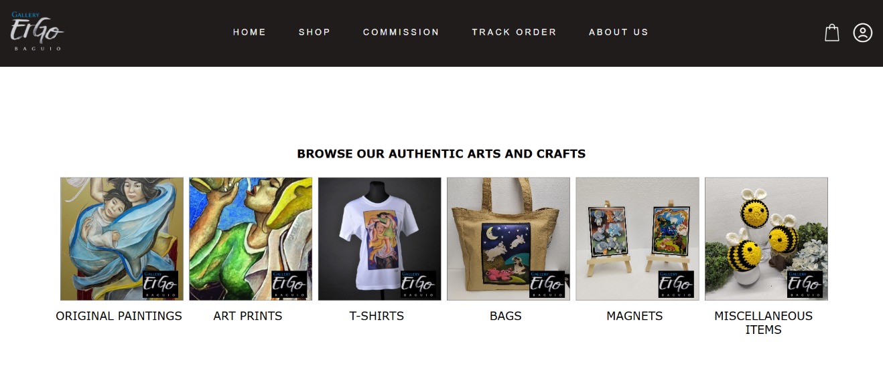

**CUSTOMER LANDING PAGE**

The customer page contains the clickable product categories:

Original Paintings

Art Prints

T-Shirts

Bags

Magnets

Miscellaneous Items

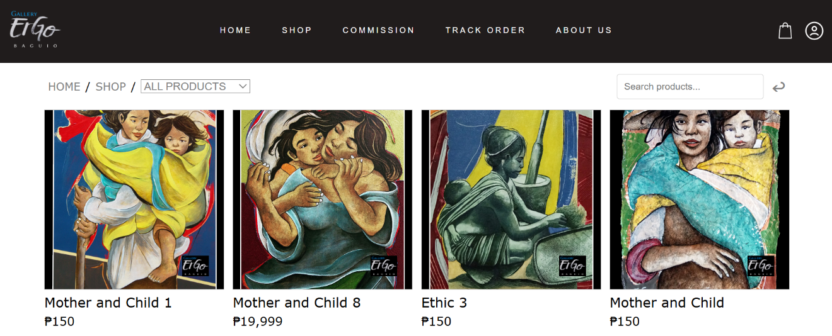

**SHOP**

Customer can browse products in the shop page by clicking on the category on the upper left or by using the search function on the upper right, then click on an item to view its details.

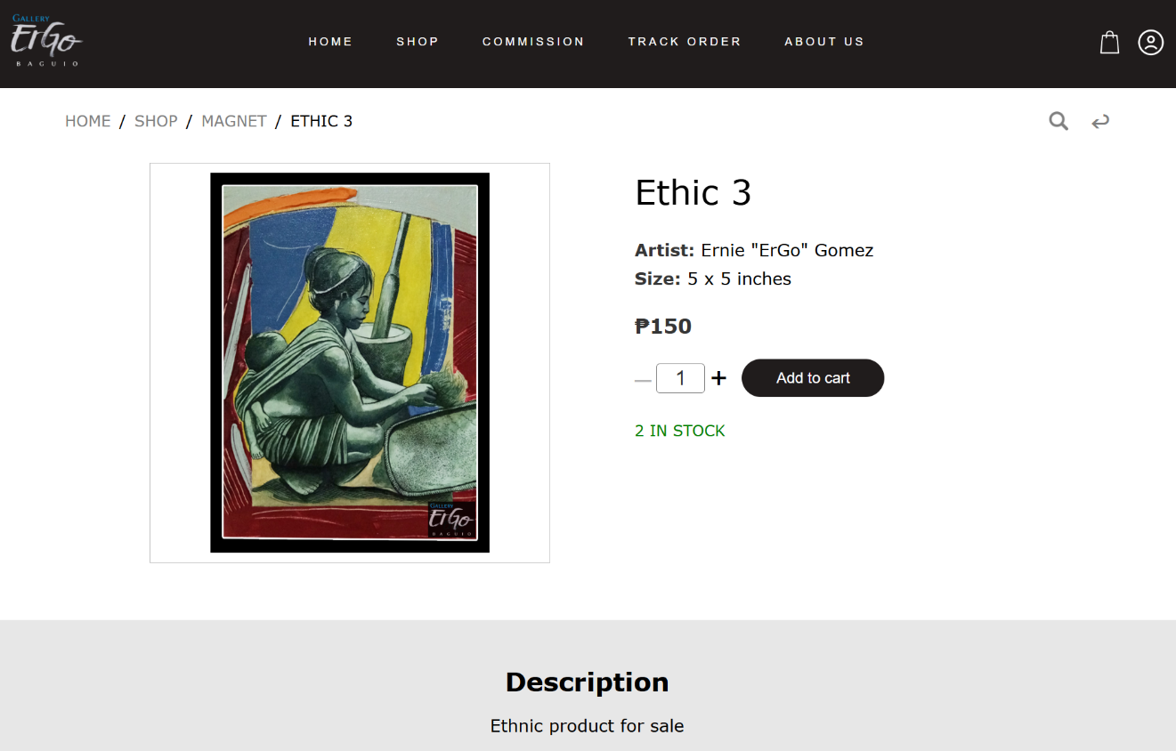**PRODUCT DETAILS**

Customer can add a product to cart by clicking on the ‘Add to Cart’ button. The quantity to be added can also be increased or decreased, depending on the number of stocks.

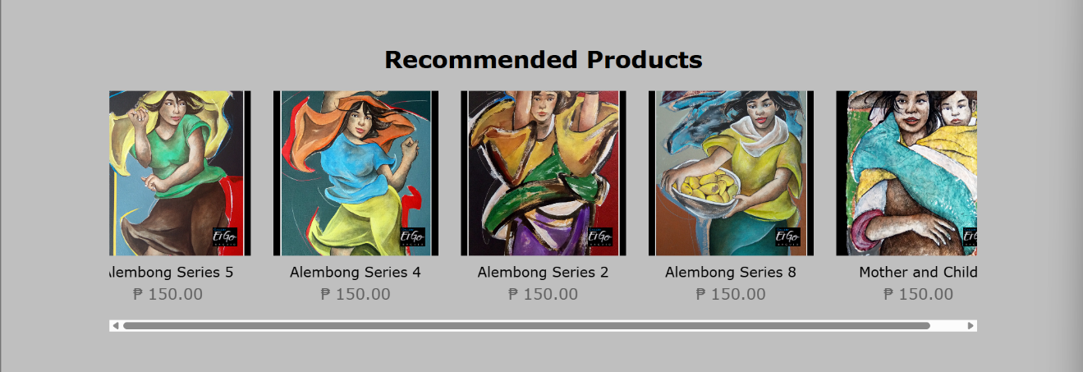**RECOMMENDED PRODUCTS**

A maximum of 5 products related to the current product by

the category or product name can be seen in this section.

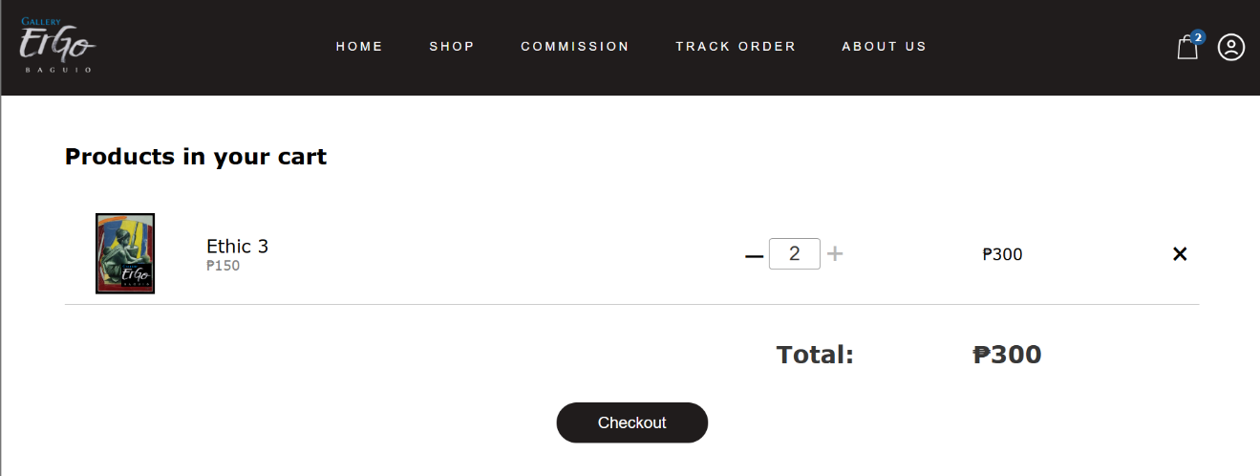**CART**

Customer can modify the items in the cart. An item can be removed, or its quantity can be increased or decreased. Click on the checkout to proceed with the order.

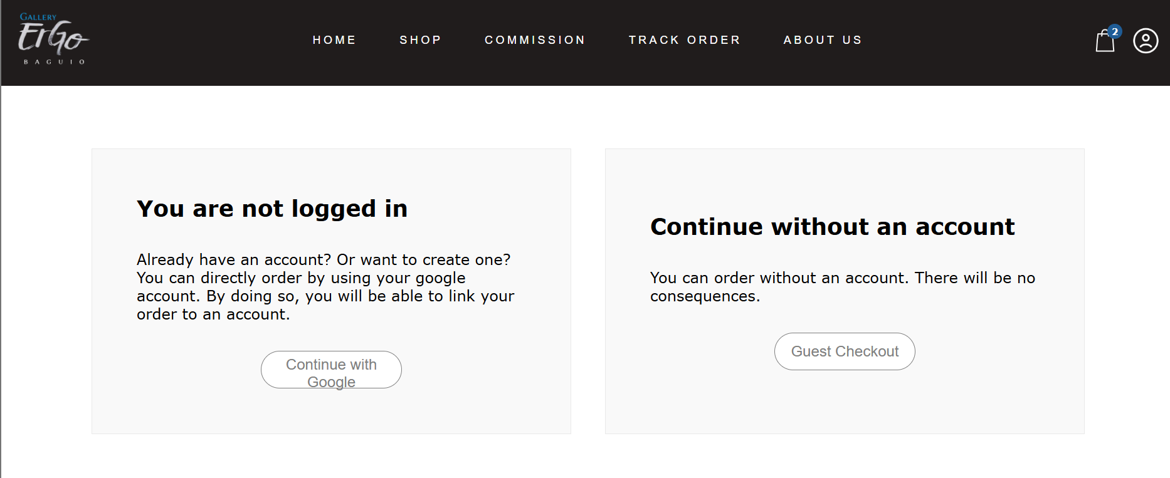**CHECKOUT**

Customer will be asked if they want to order with or

without logging in with Google. Click on ‘Continue with Google’ to go to the login page, or click on the ‘Guest Checkout’ to order without creating or logging into an account.

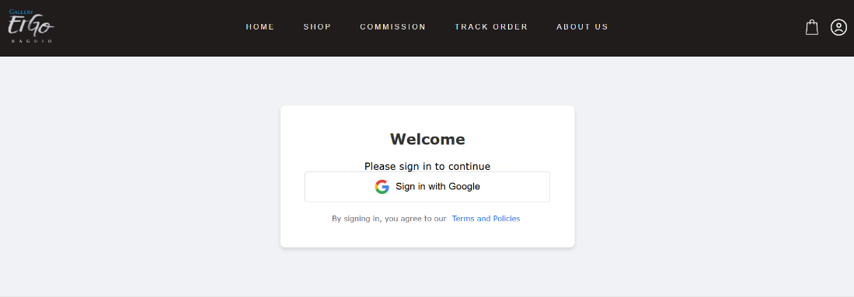

**LOGIN**

Clicking on ‘Sign in with Google’ will redirect the customer to Google’s login page, where they can login to the website using their Google account.

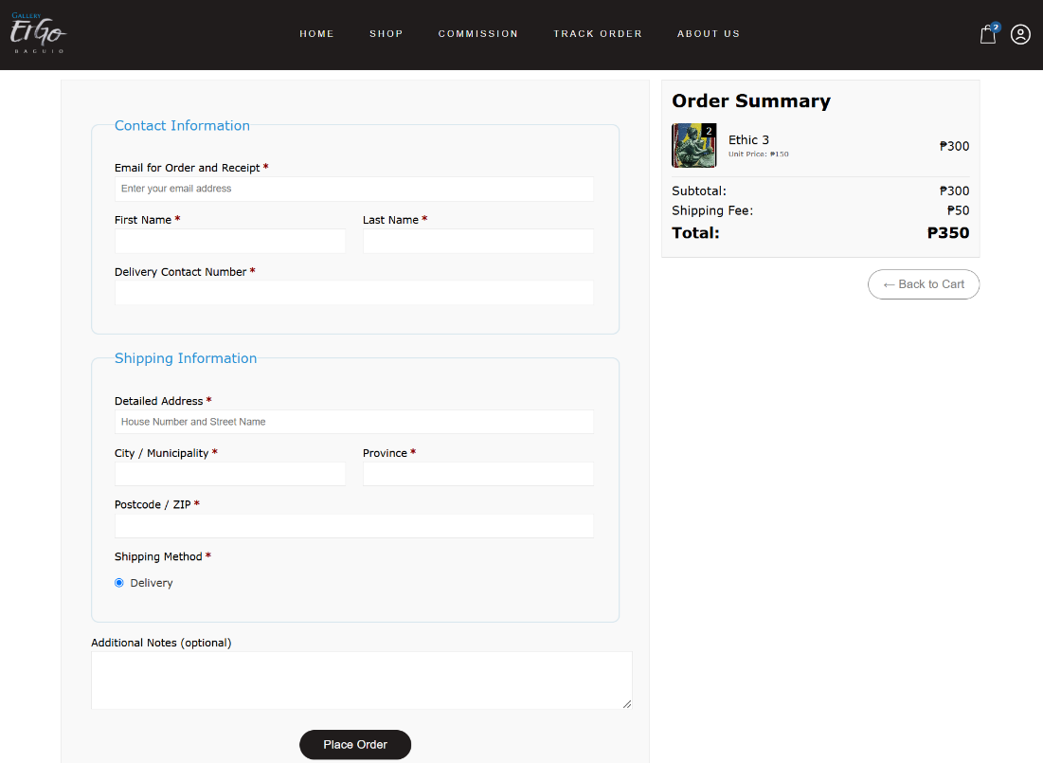

**CHECKOUT FORM**

Customer must enter their details before placing an order. These details include contact and shipping information.

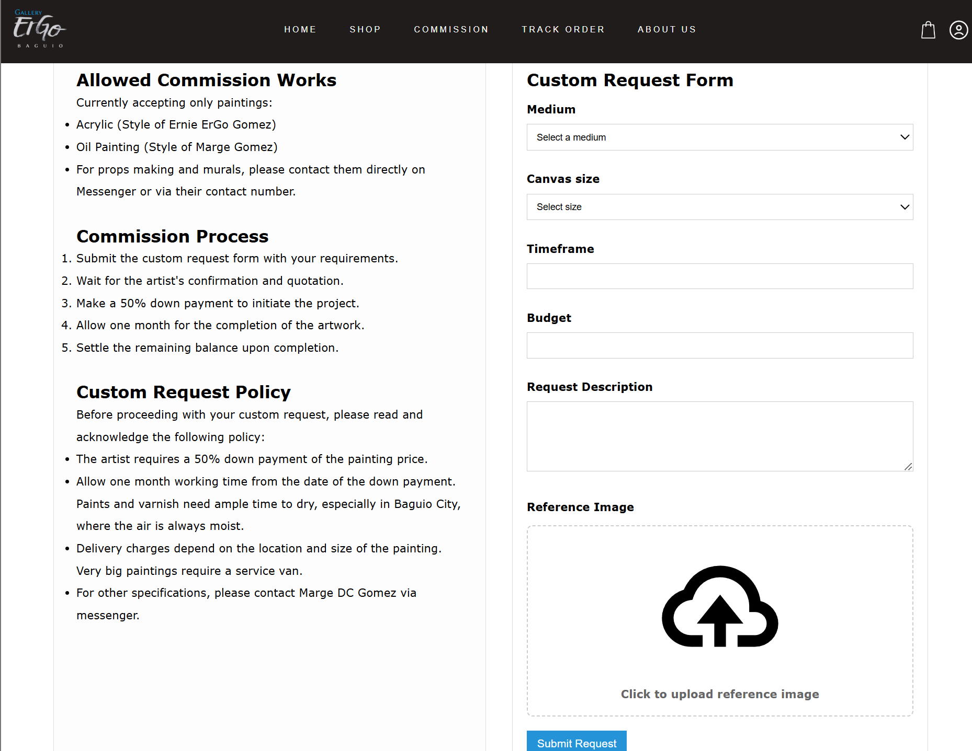**COMMISSION POLICY AND PROCESS**

To order a custom painting from the artist, the customer must acknowledge that they have read and understood the commission policy and process by clicking on the ‘I Acknowledge’ button. The custom request form will show up, and the customer must enter the details of their custom request, then click on ‘Submit Request’.

Appendix H

SalesVista User Manual: Admin

\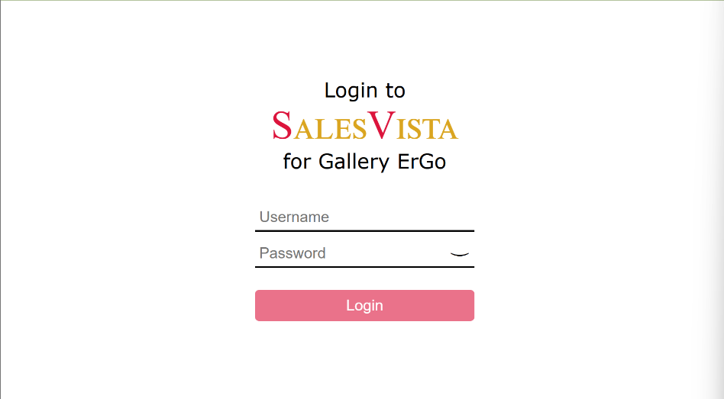

**LOGIN**

The admin will have to login by entering their username and password. After putting the username and password, click the ‘Login’ button.

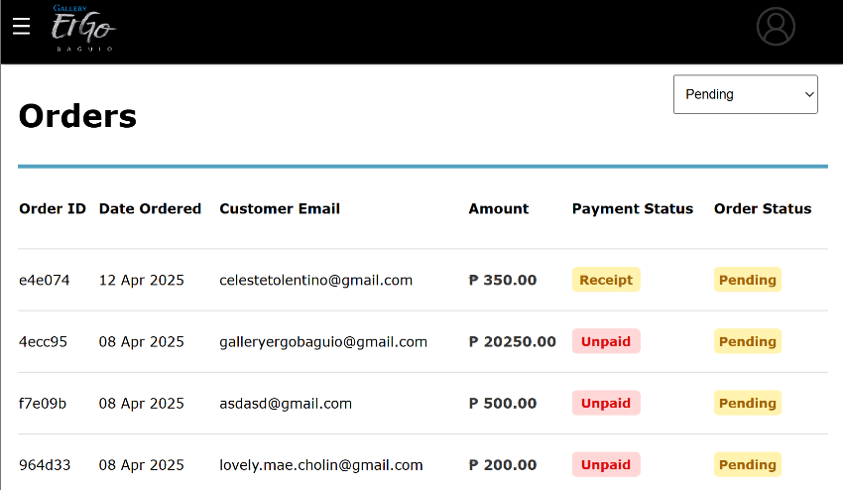

**ORDERS**

The admin can view the orders made on the website. It will display the order id, date ordered, customer email, amount, payment status, and order status. At the upper

right corner, you can filter the orders by the different order statuses. Click on an item to review an order.

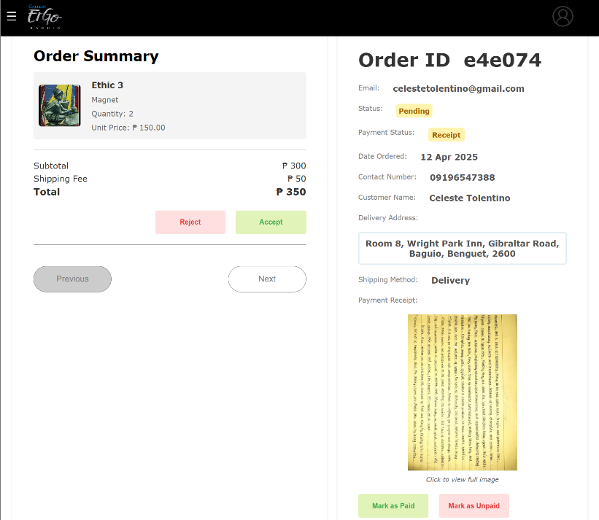

**ORDER DETAILS**

In the order details, the admin can accept or reject the order. The admin can also view if the customer has uploaded a receipt of their payment, then they can set the order as paid or unpaid.

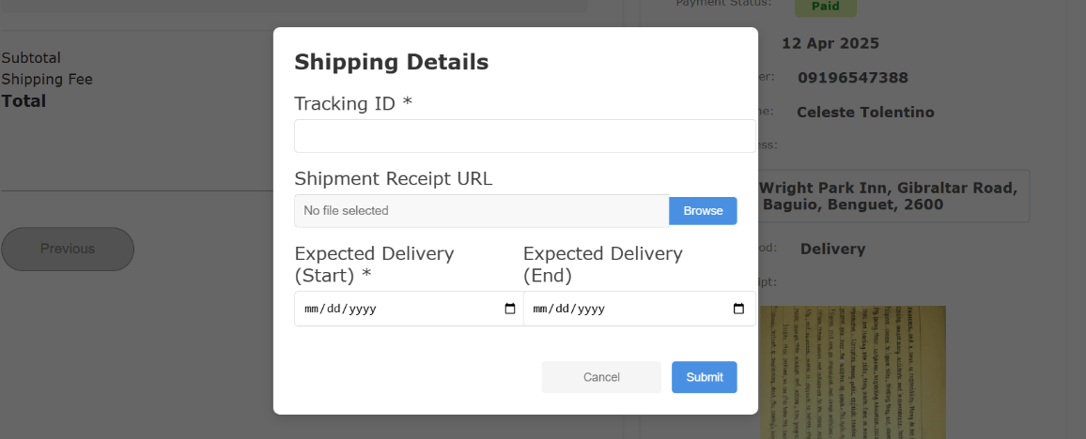

**SHIPPING AN ORDER**

The admin must enter the tracking ID and expected delivery date of the order, and an optional shipment receipt image.

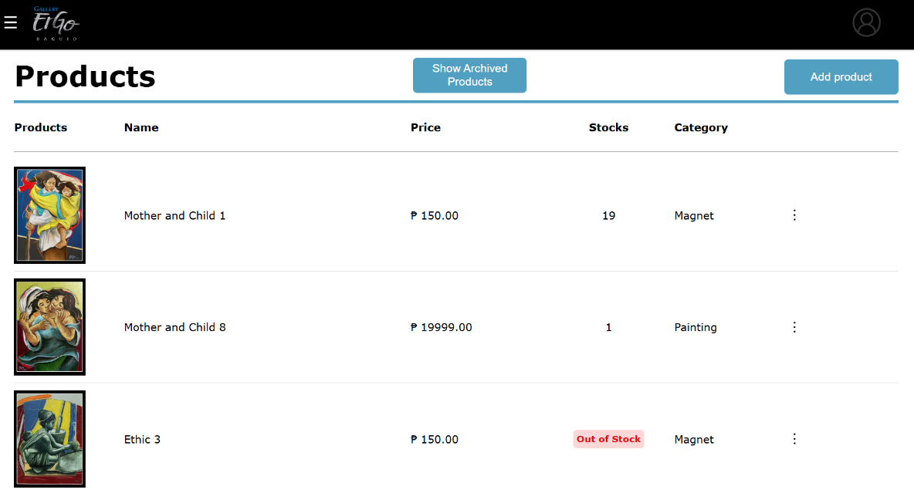

**PRODUCTS**

The admin can also view the products uploaded where it shows the product, name, price, stocks, and category. On the top corner, there is an add product button where the admin can add a product on the website. On the top middle, there is the show archived products where you can view the products that you have archived.

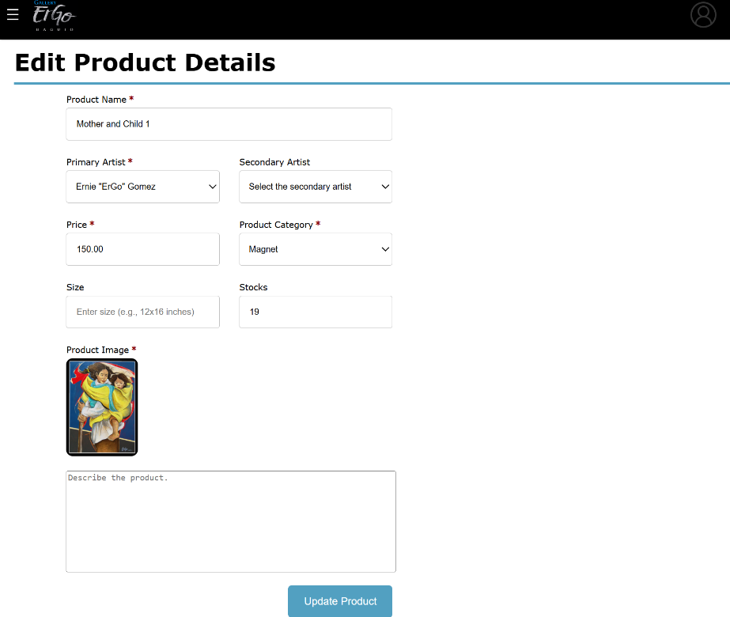

**EDIT PRODUCT**

A product can be edited by pressing the edit product button from the three bullets in the products page. The admin can edit the product name and other fields. After filling out the fields, click the update product below.

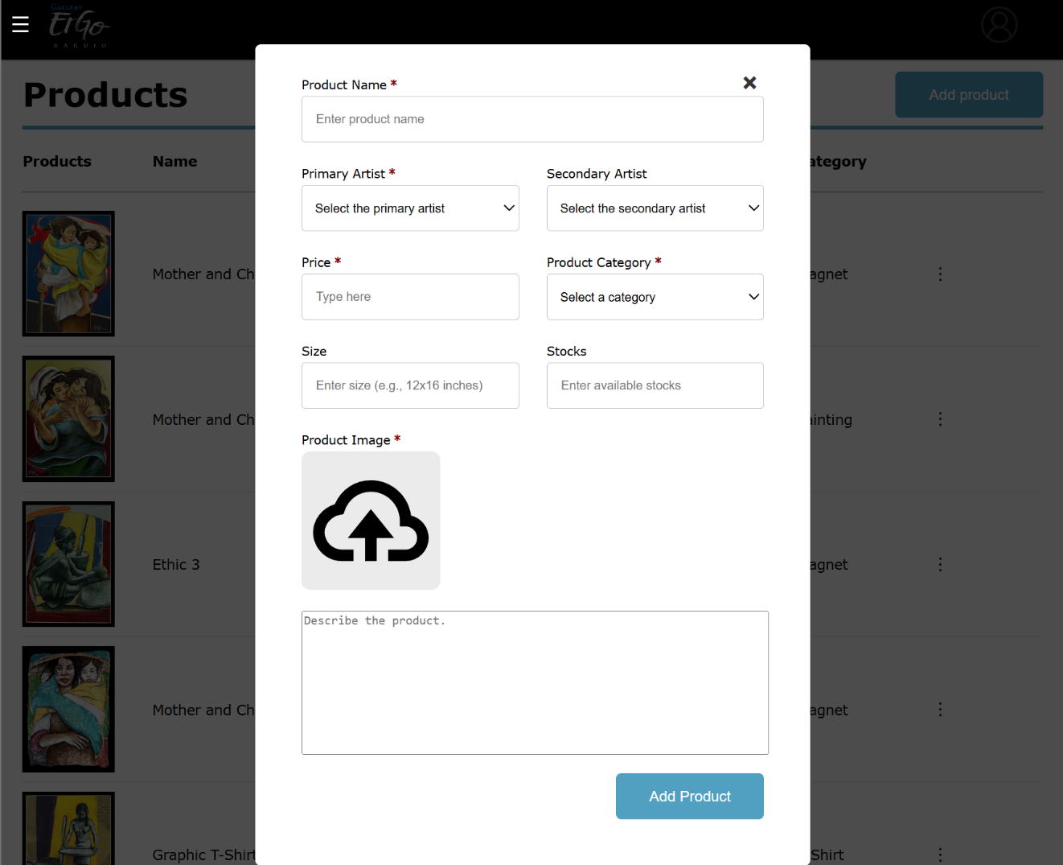**ADD PRODUCT**

The admin can add product by clicking the “Add Product” button at the top right corner of the products page. After clicking, there will be a pop up where you need to fill the fields with the product name, primary and secondary artists, price, category, size, stocks, product image and description. After filling the required fields, click the ‘Add Product’ below.

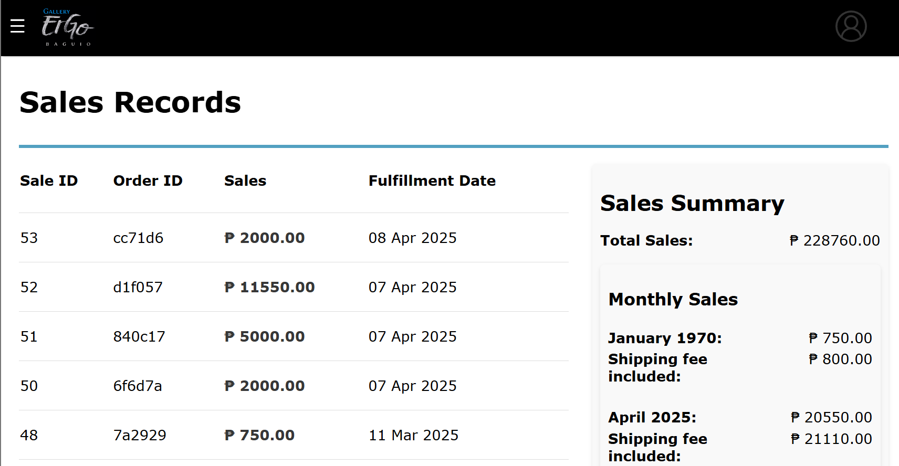**SALES**

The admin can view list of sales made where they can see the sale ID, order ID, sales, fulfillment dates, and the sales summary. In the sales summary, it is separated by the total sales and the sales per month.

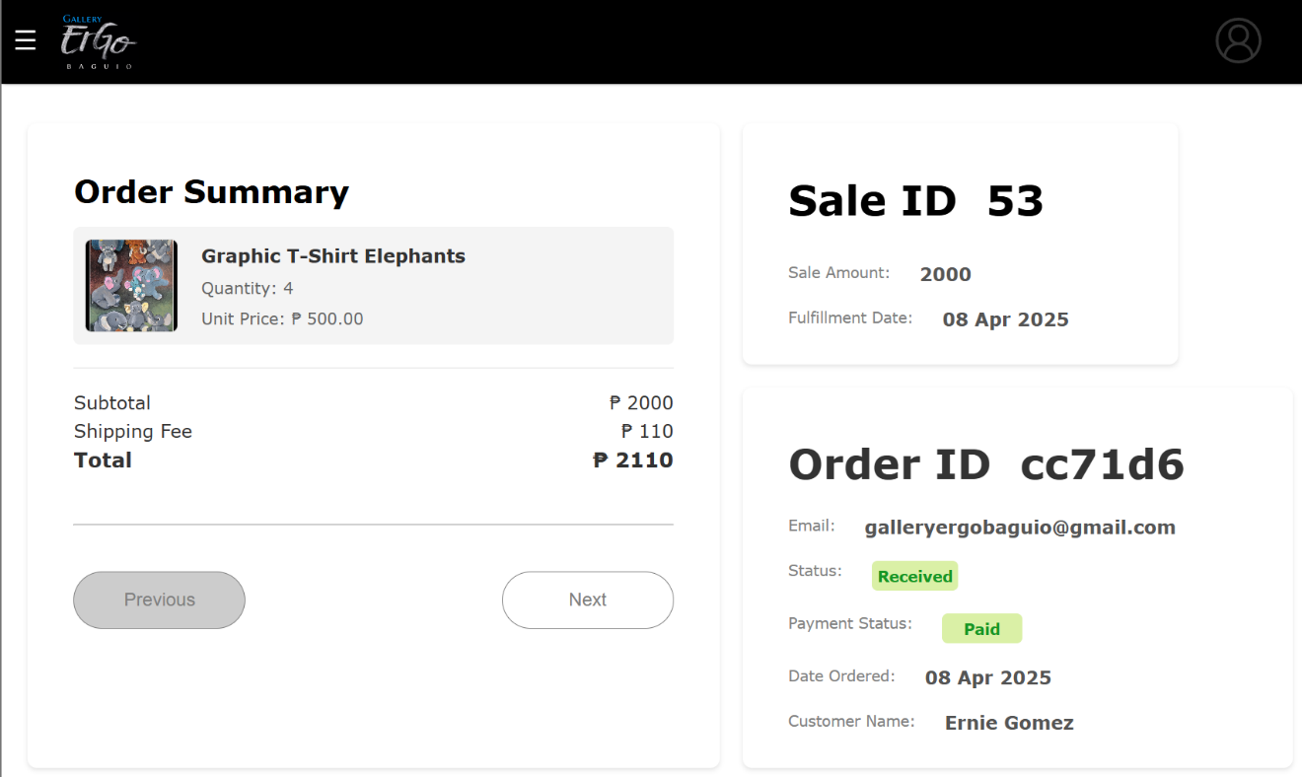**SALES RECORD**

A sales record contains the sale and order information. The admin can view the product/s sold, quantity, total prices, sale ID, and the information provided by the customers.

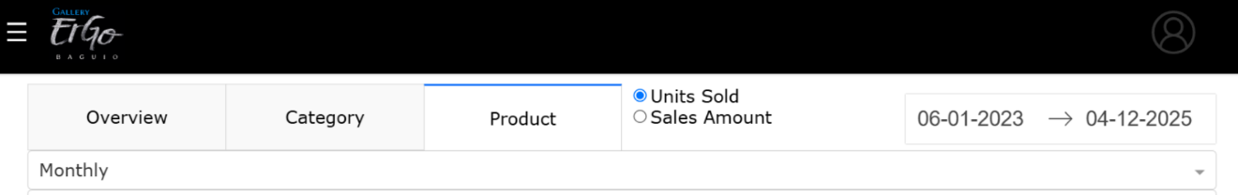**DASHBOARD OPTIONS**

The dashboard options can always be seen while in the dashboard, in all tabs, and the dashboard has three tabs that show different graph/s and data. The dashboard’s graphs and data can be manipulated to show data of a

specific date range by clicking the date range picker on the upper right and picking the start and end dates. The graphs and data can also be manipulated to display results based on the units sold or sales amount by choosing between the two radio buttons on the left of the date range picker. Data can also be grouped daily, weekly, or monthly by using the dropdown button.

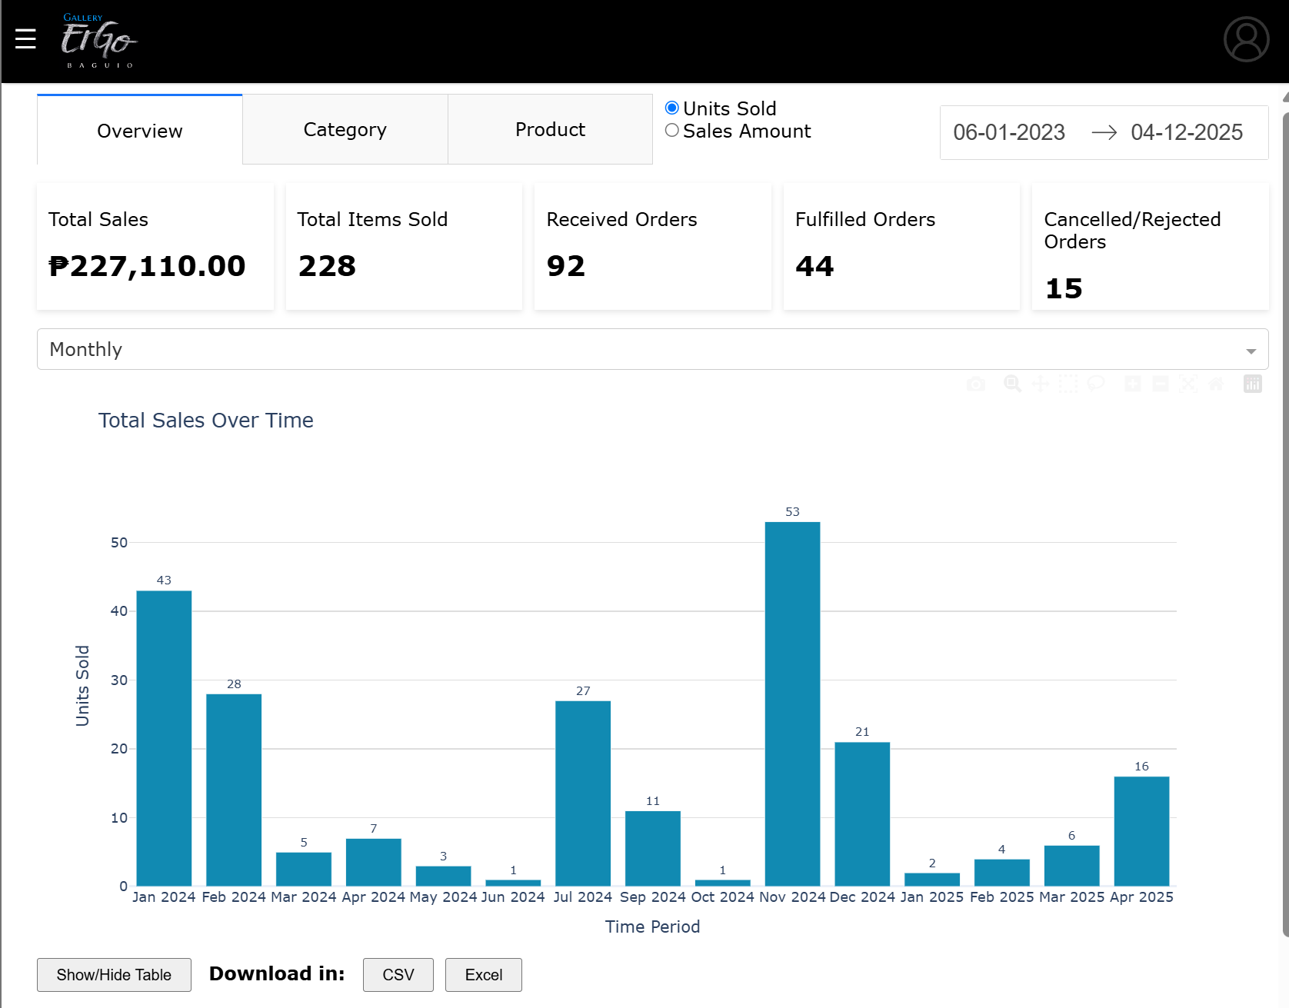**DASHBOARD OVERVIEW**

The Overview tab displays summary of total sales, total items sold, received orders, fulfilled orders, and

cancelled/rejected orders. It shows the Total Sales Over Time grouped bar chart, which has a viewable and downloadable (.csv and .xlsx) table. Two other graphs: Top 10 Products horizonal bar chart, and Sales Performance by Category pie chart.

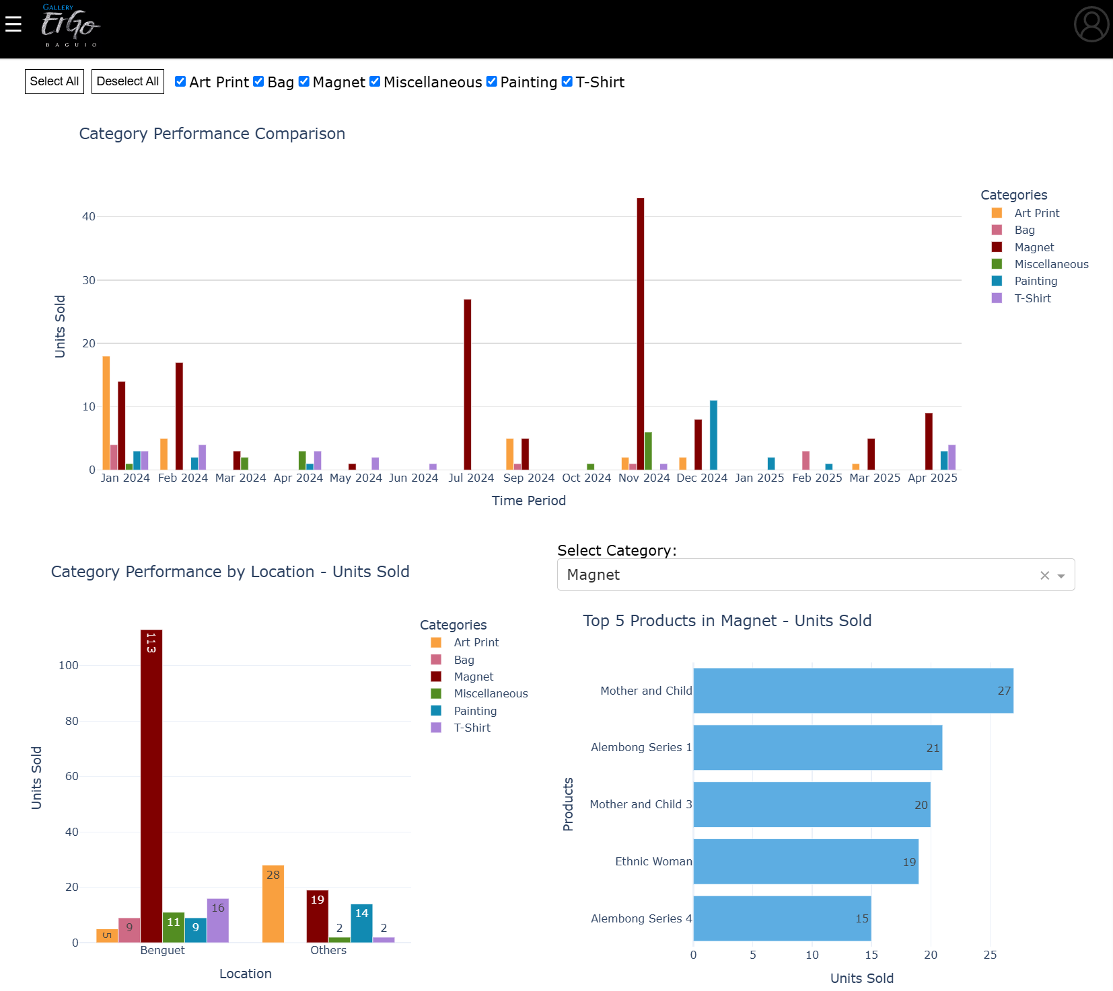**DASHBOARD CATEGORY**

The category tab displays three graphs: Category Performance Comparison grouped bar chart, Category

Performance by Location grouped bar chart, and Top 5 Products per Category horizontal bar chart.

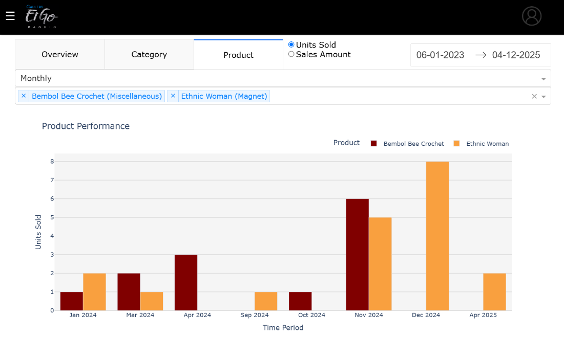

**DASHBOARD PRODUCTS**

The products tab allows the admin to search for and view the performance of up to 5 products for comparison. This can be done by clicking on the input field below the time aggregation dropdown button and searching for the product’s name or category. If a searched product does not appear in the graph, it means no sale has been made with that product.